

root@cyberster:~$ whoami
> hanzallah — soc_intern
Day
67-73
Case File: Mantooth - Digital Forensics Investigation
// candidate Hanzallah
// program Cyberster — Cybersecurity Internship (Batch 2)
// tutor Abdullah Zia
[ STATUS: TASKS COMPLETE — READY FOR REVIEW ]
Days 67–69: Lab 1 Autopsy Triage & Artifact Hunting
Case: Mantooth Financial Fraud Investigation | Tool: Autopsy 4.21.0

$ Chain of Custody — Data Source Integrity
Evidence File: Mantooth.E01
Case Time Zone: Mountain Time (America/Denver) — set prior to Add Data Source
MD5 Hash (Data Source Integrity module):
Integrity Status: Verified — "Integrity of Mantooth.E01 verified" (Ingest Inbox, Data Source Integrity module)
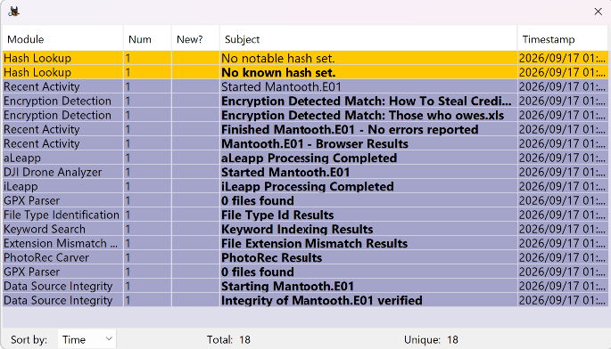
// 01 STEP 1 — CASE CREATION & IMAGE VERIFICATION

Q1. What is the MD5 hash of the Mantooth.E01 image as verified by Autopsy?
Artifact: Data Source Integrity module result
Path/Tool: Autopsy → Data Source Integrity ingest module
Finding: Data Source Verification Results for Mantooth.E01
- Result: verified
- MD5 hash verified
  - Calculated hash: 31217210a1a69f272079a3bde3d9d8fc
  - Stored hash: 31217210a1a69f272079a3bde3d9d8fc

Q2. How many partitions are on the evidence image? Include file system type, size, and offset for each.
Artifact: Volume/partition table
Path/Tool: Autopsy → Data Sources tree → Mantooth.E01 volumes

Volume | File System | Sector Range (Offset) | Notes
vol1 | Unallocated | 0 – 62 | —
vol2 | NTFS / exFAT (0x07) | 63 – 224909 | [CONFIRM — contains Windows install; verify via boot files]
vol3 | DOS FAT12 (0x01) | 224910 – 240974 | —
vol4 | Unallocated | 240975 – 250878 | —
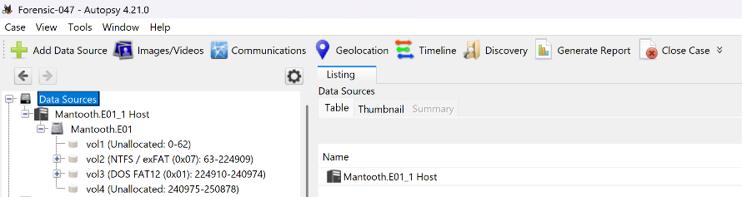
// 02 STEP 2 — TARGETED TRIAGE

Q3. Which photo was taken by an Olympus Optical device? Document filename, path, and identifying EXIF fields.
Artifact: EXIF Metadata
Path/Tool: Autopsy → Analysis Results → EXIF Metadata (8 hits)
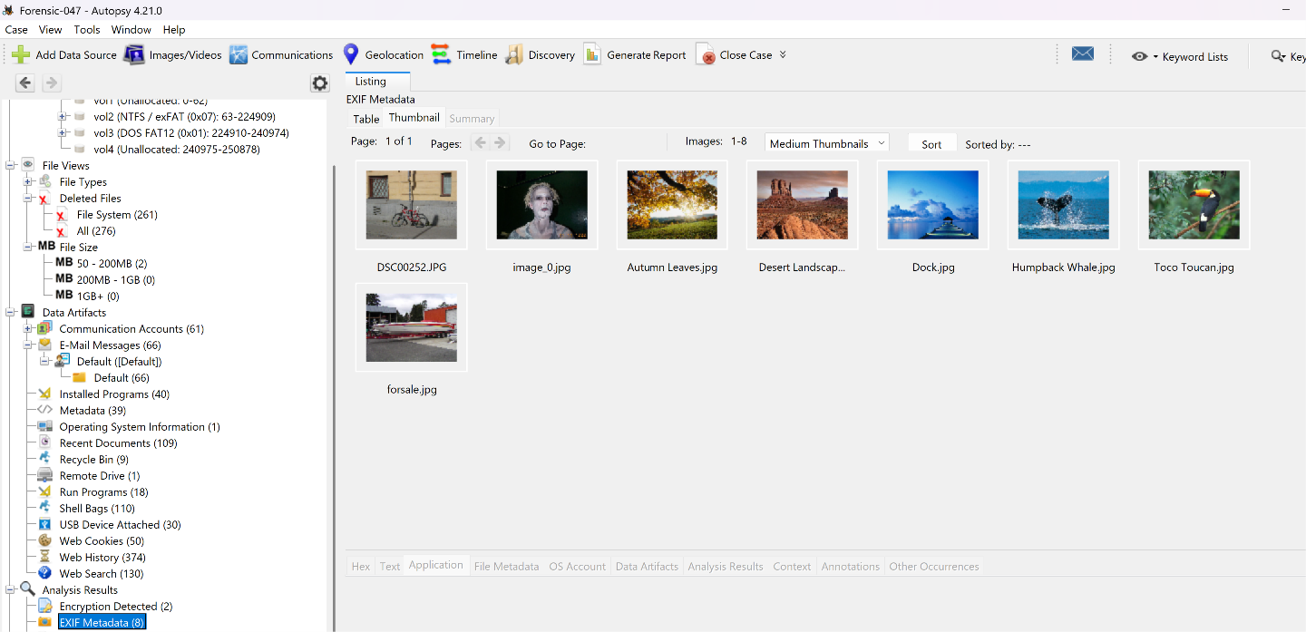
Q4. Which file is encrypted? Document filename, location, and indicators.
Artifact: Encryption Detected
Path/Tool: Autopsy → Analysis Results → Encryption Detected (2 hits)
Candidate Files: "How To Steal Credi[t...].???" and "Those who owes.xls" — [CONFIRM full filenames + paths in Encryption Detected panel]
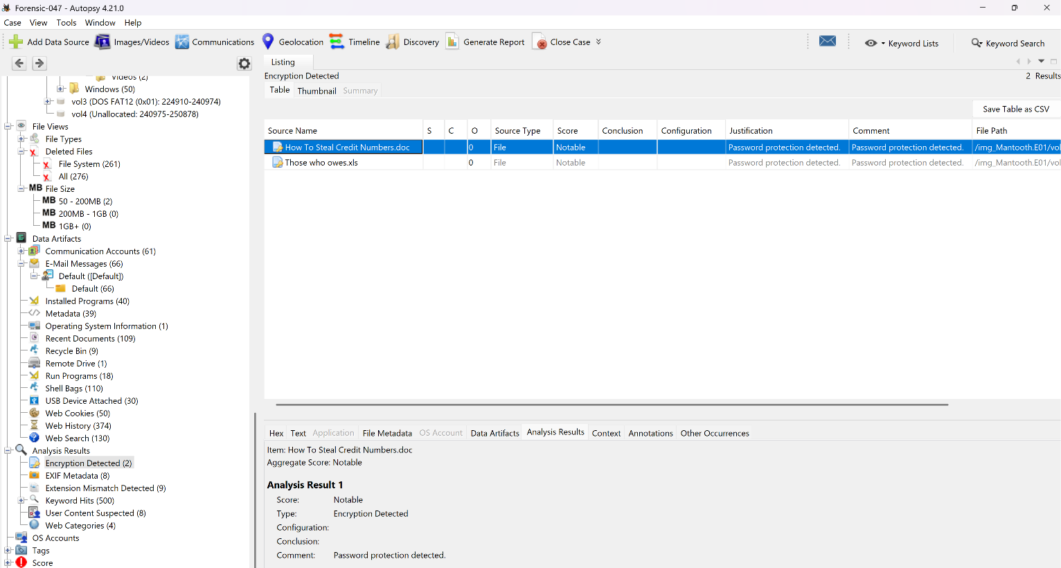
Q5. What happened to HARDCORE.jpg and pfah603.jpg? Deleted? Recoverable?
Artifact: Deleted Files
Path/Tool: Autopsy → File Views → Deleted Files, or direct filename search
HARDCORE.jpg — Status/Path: Active
pfah603.jpg — Status/Path: Active
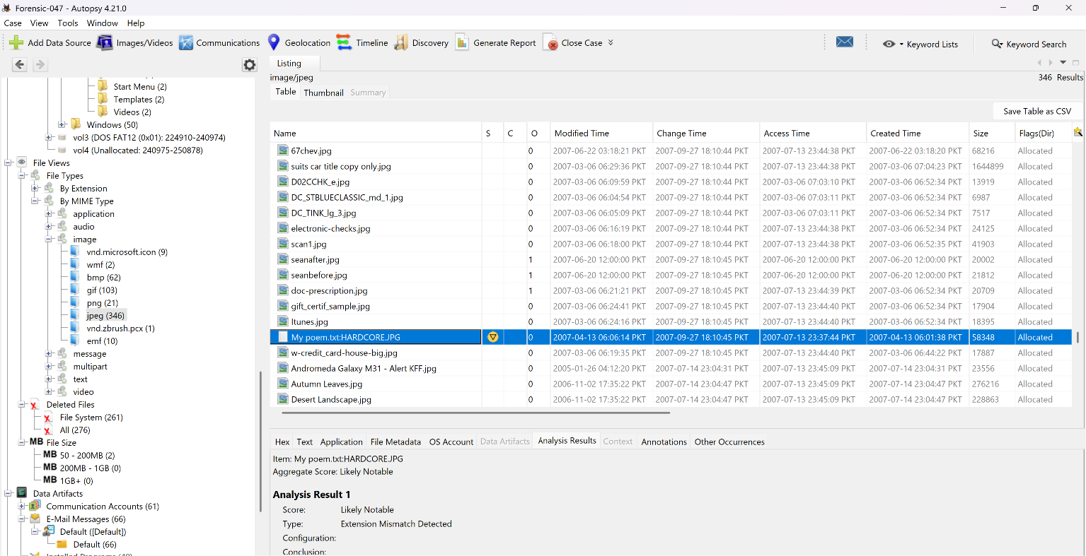
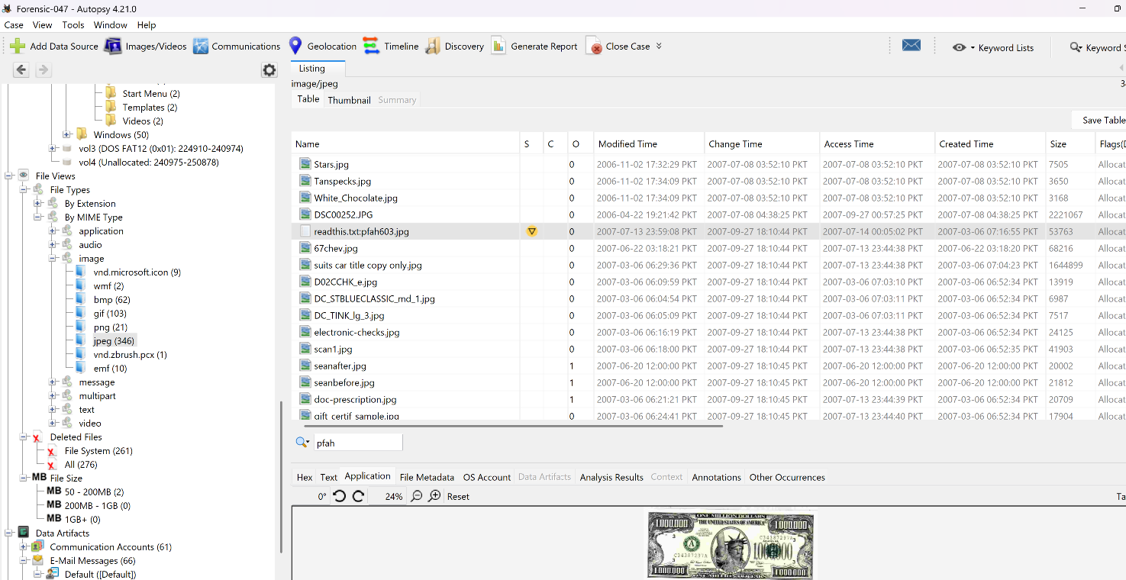
Q6. Review web search history — three main topics, terms, dates, and browser/engine.
Artifact: Web Search
Path/Tool: Autopsy → Data Artifacts → Web Search (130)
Topic 1: check washing
Topic 2: making meth
Topic 3: atm card stealing
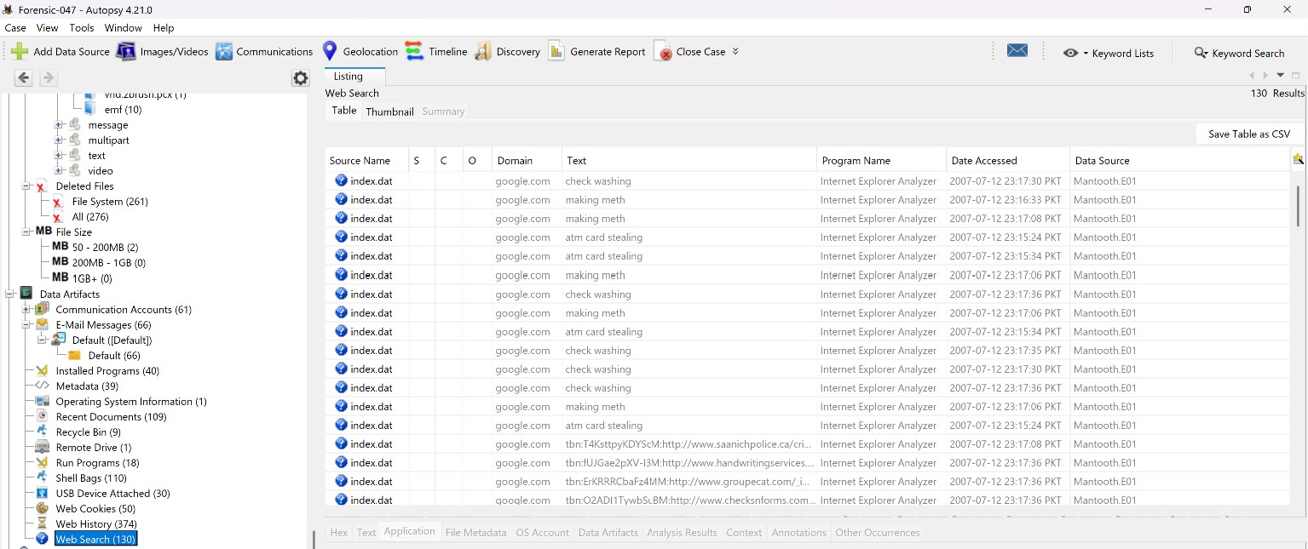

Q7. List three IP addresses and three email addresses, with context.
Artifact: Email Messages / Web History
Path/Tool: Autopsy → Data Artifacts → E-Mail Messages (66), Web History (374)
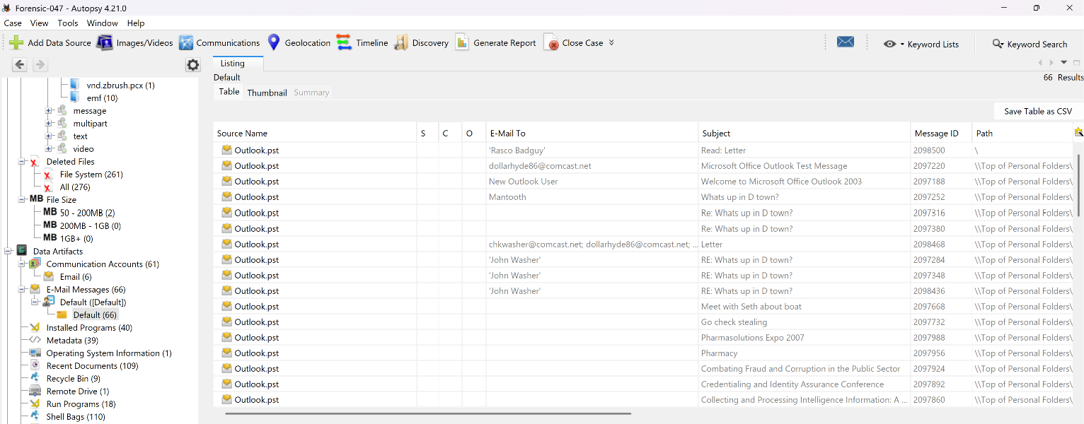

// 03 STEP 3 — WINDOWS ARTIFACT HUNTING
Q8. User accounts on the system, and ≥10 investigatively suspicious files in Wes Mantooth's directory.
Artifact: OS Accounts
Path/Tool: Autopsy → OS Accounts; Users\Wes Mantooth\
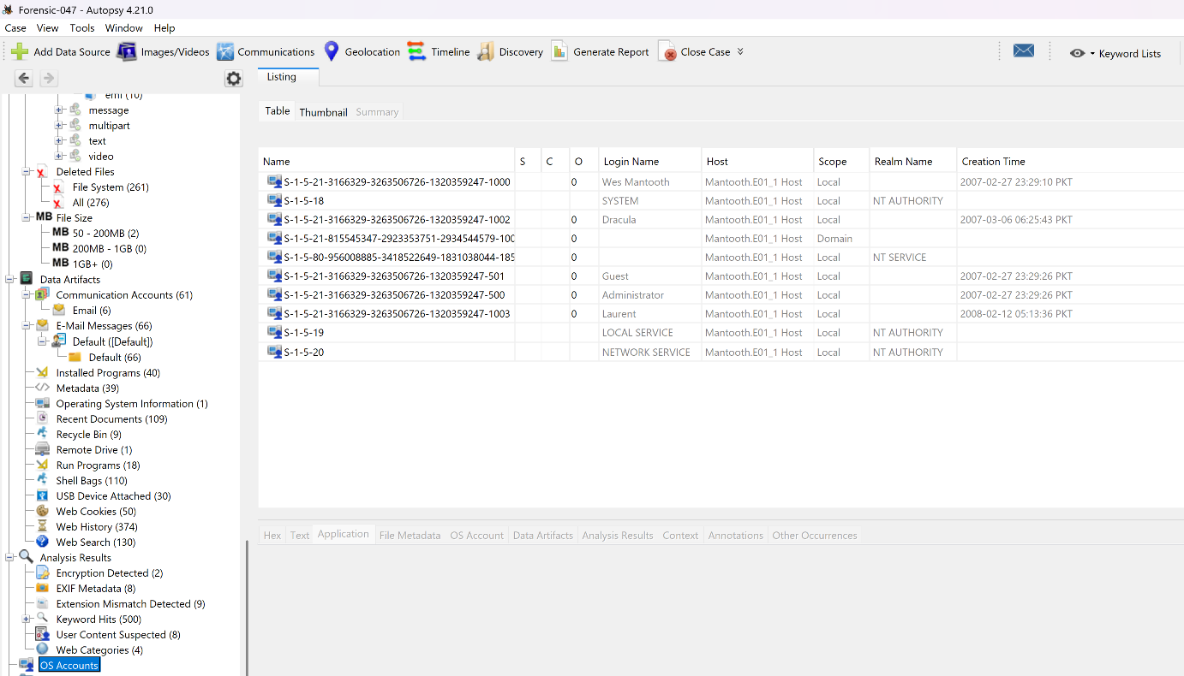
Q9. Thumbcache databases for Wes Mantooth — files, thumbnail count, significance.
Path/Tool: Users\Wes Mantooth\AppData\Local\Microsoft\Windows\Explorer\thumbcache_*.db
Databases Found: YES
Thumbnail Count: 6
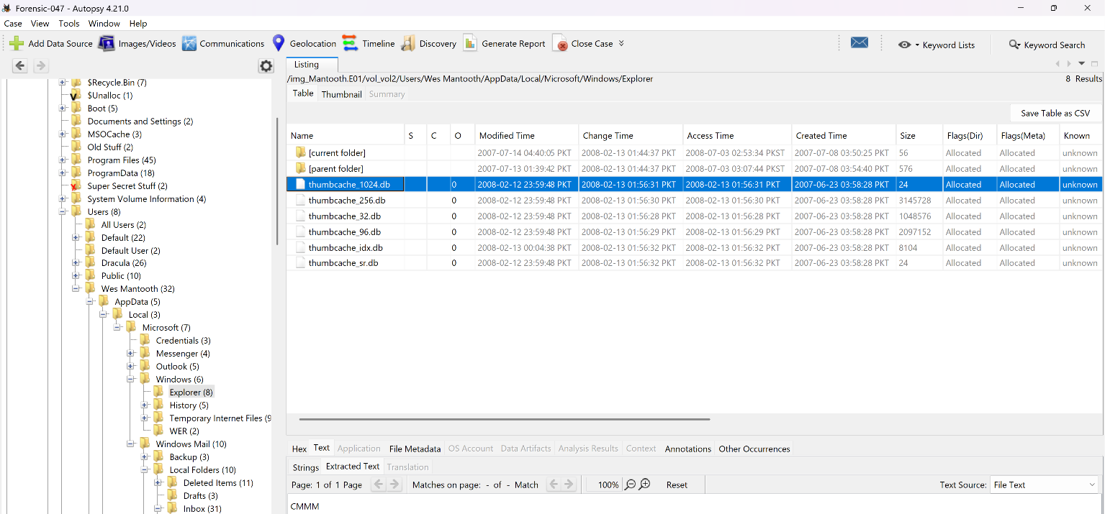
Q10. $I / $R pair for Camerashy.exe in Recycle Bin — original path, delete time, recoverability, and research findings.
Path/Tool: $Recycle.Bin\<SID>\ — Recycle Bin data artifact (9 entries)
Original Path: C:\Users\Wes Mantooth\Documents\CameraShy.exe
Deleted (Recycled) Time: 2007-07-14 22:55:57 PKT
Recoverable: YES
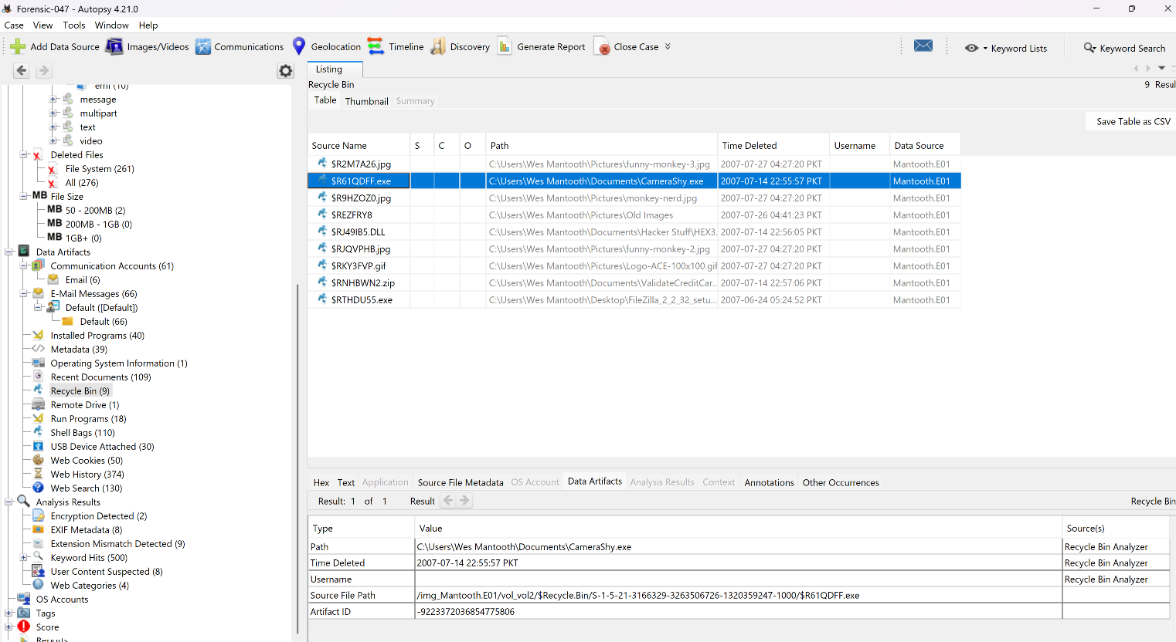
Q11. Prefetch entry for Xcopy — filename, embedded exe path, run count, last execution, significance.
Path/Tool: Windows\Prefetch\XCOPY.EXE-*.pf
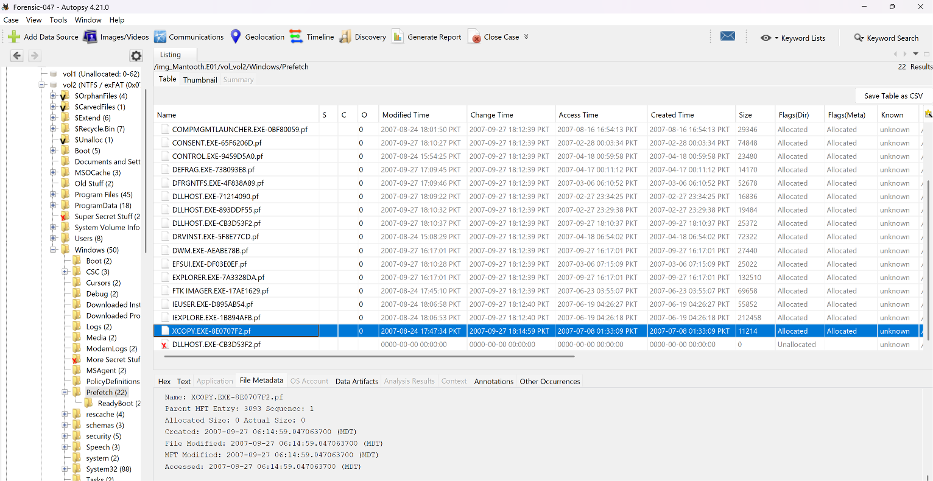
Q12. LNK files for Wes Mantooth — target path, timestamps, target still present?
Path/Tool: Recent Documents data artifact (109 entries)
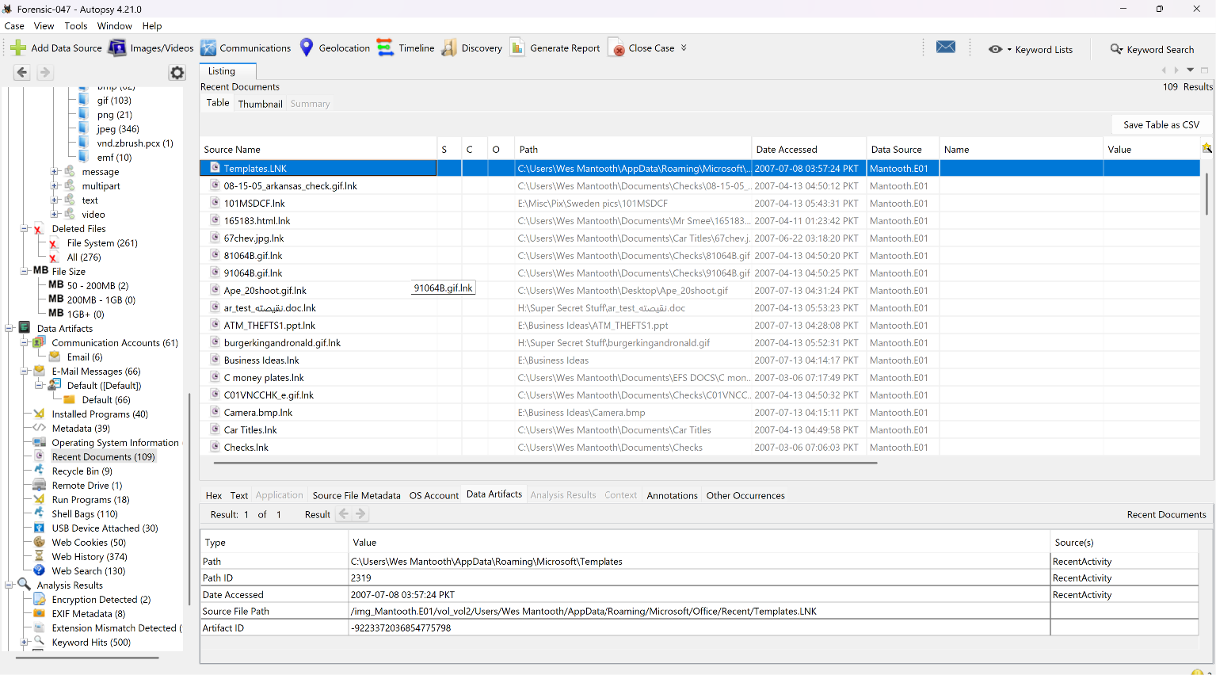
Q13. Print spooler directory — spool files, sizes, print job metadata.
Path/Tool: Windows\System32\spool\PRINTERS\ (.SPL/.SHD)
Files Found: YES
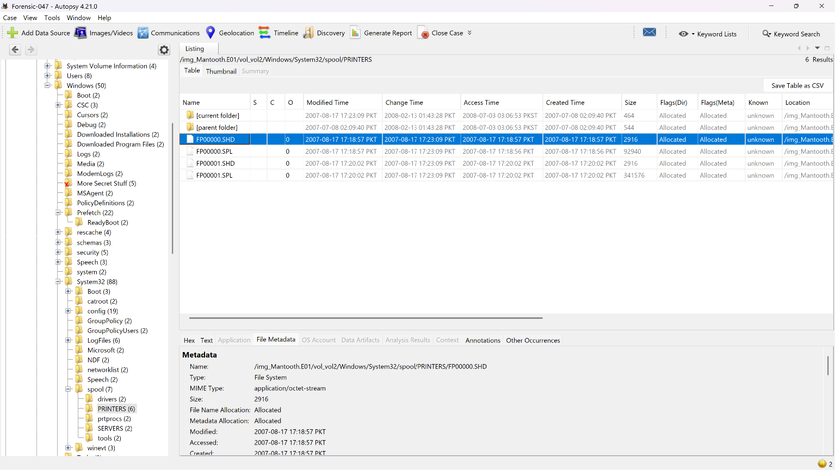
Q14. Security.evtx — logon/logoff times, event IDs, logon types, session durations for Wes Mantooth.
Path/Tool: Windows\System32\winevt\Logs\Security.evtx
